Annex
Exam Location and Transport Route
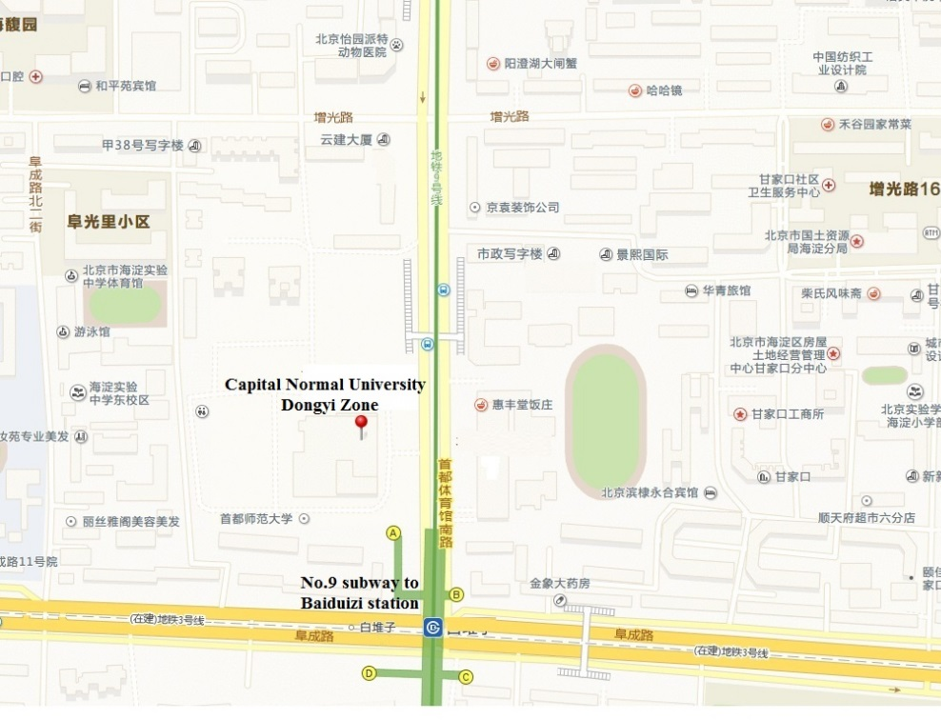
Subway: No.9 subway to Baiduizi station exit A, 50 meters to North.
- Bus: No. 61 / 92 bus to Shouti South Road South Gate station, No. 121/56/37 or Yuntong 106 to Baiduizikoudong station, BRT 4 to Baiduizikouxi station, 3 minutes’ walk to the destination.
Kind reminder: Capital Normal University Dongyi Zone is not located in the main campus of Capital Normal University, please plan your route properly.

